- SCOPE

The specific purpose for this Work Instruction is to provide detail instructions for the use of the climate sites tab in the MWQM CSSP Web Tools.

- REFERENCES

CSSP Web Tools at this address: http://wmon01dtchlebl2/

- PROCEDURE

The climate site tab’s primary use is to get precipitation values that will be used in the analysis function under the MWQM sites tab.

In order to set climate sites for each subsector and ask the tool to get climate data semi- automatically a few steps are required.

- Select relevant climate sites for the subsector (See section 3.4.1)
  - You should not select too many or too few climate sites or climate sites that are too far. Try to have at least 2 climate site to cover every year of samples
  - Use climate sites with the most years with data (try to stay away of climate sites with only a few years of data)
  - Keep in mind predominant winds and the location of the climate site in relation with the watershed of the subsector
- Set priority of each climate site selected for the subsector (See section 3.4.2)
  - A good practice is to look at the distance of each climate site
  - Also take into consideration the predominant winds and location of the climate site in relation with the watershed of the subsector
- Upload all the climate sites data for every year by using the features in the ‘Climate sites data for each run’ section (See section 3.4.3)
- Once you have uploaded the data, you need to indicate if you want to use the data from priority site first or use the average of your available data.
  - Using average if you have too many climate sites and/or climate sites that are too far from the subsector will flatten peak precipitation which is not what you might be looking for. Caution when using average on too many climate sites or climate sites that are too far.

3.1. Open CSSP Web Tools at this address: http://wmon01dtchlebl2/

3.2 Click on: ‘Latest CSSP Web Tools’

3.3 Click on: Start Using CSSP Web Tools. If you were not logged on previously you will have to log in. Click on ‘Log in ’, Enter your e-mail and password and then click on ‘Start Using CSSP Web Tools’

3.4 Click on: ‘Canada’, select a province and navigate to the subsector of interest. Select the ‘Climate sites’ tab. Your screen should look like (see page 2).

3.4.1 Climate sites and years of use: The default page in the climate sites tab displays all the climate sites available within 50 km of that subsector. The user can change the default distance by typing the desired distance in the available box and clicking on the ‘Find’ button.

You also have the option of opening the map feature to see where the climate sites listed are located relative to the subsector polygon by clicking on the ‘Show climate sites on map’ button. Clicking on the individual map marker icons next to each climate site name will locate on the map the specific site. The map identifies each climate site with a 3 digit number that can to be traced to the list of climates sites.

Each climate site has an identifier (3 digit number), a name, climate site ID number, the range of date/years for which there is data available and the distance of the climate site from the subsector. If you see the word ‘NOW’, this means that the site is still active to the best of our knowledge.

To select priority sites for each subsector, users have 2 options:

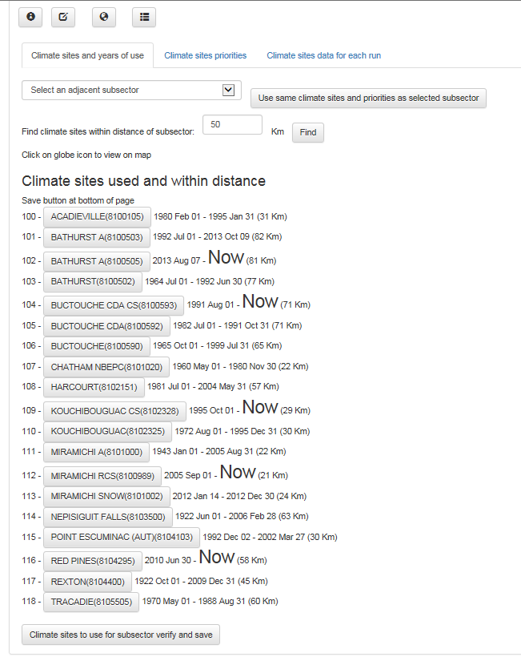

3.4.4.1 Click on individual climate sites, specify the range of years for which this site is to be used following the rules outlined by clicking the button (see below picture) and then click on the ‘climate sites to use for subsector verify and save’ button at the bottom of the page

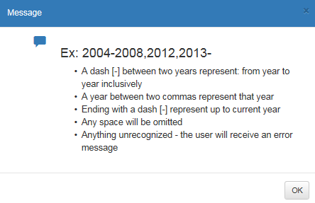

3.4.4.2 An alternative method for selecting climate sites for a particular subsector is to copy the selection made at an adjacent subsector. To do this, select from the first drop down menu box the subsector you would like to copy 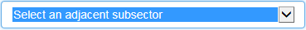 and then click on the button.

3.4.2 Climate sites priorities: Clicking on this option will open up a new screen that will look like:

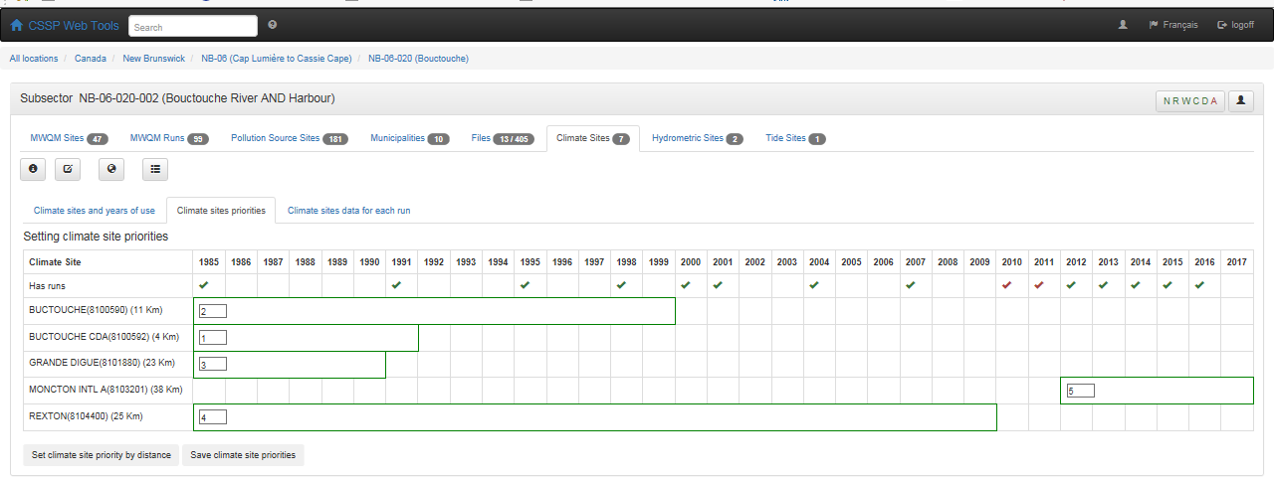

This section allows you to see what years have sampling runs/data and whether or not there is climate sites data covering those years. The selection you have made in the previous section (Climate sites and years of use – 3.4.1) will be listed here. In the above example, all the green check marks represent years where there is climate data covering the sampling run year and red check marks represents years where there is no climate data covering that year.

It is important to have multiple climate sites covering the same years, that all check marks are green and that you set the priority in which the climate data should be used. To do this, type in number 1, 2, 3, etc. in the black boxes next to each climate site name and then click on the at the end. You can set priorities based either on the distance from the subsector (in bracket next to climate site name) or by taking into consideration the watershed of the subsector. If you want to set the priorities base on distance, click on button and then the ‘save climate site priorities’ and the system will do it automatically for you.

You need to do this exercise for each subsector but the system will remember your selection (priority) for future sampling years however you must go in the next section (Climate sites data for each run- 3.4.3) each year to load that data (Charles working on this being automatic once supervisors accept the data sent from the input tool).

3.4.3 Climate sites data for each run: Clicking on this option will open up a new screen that will look like:

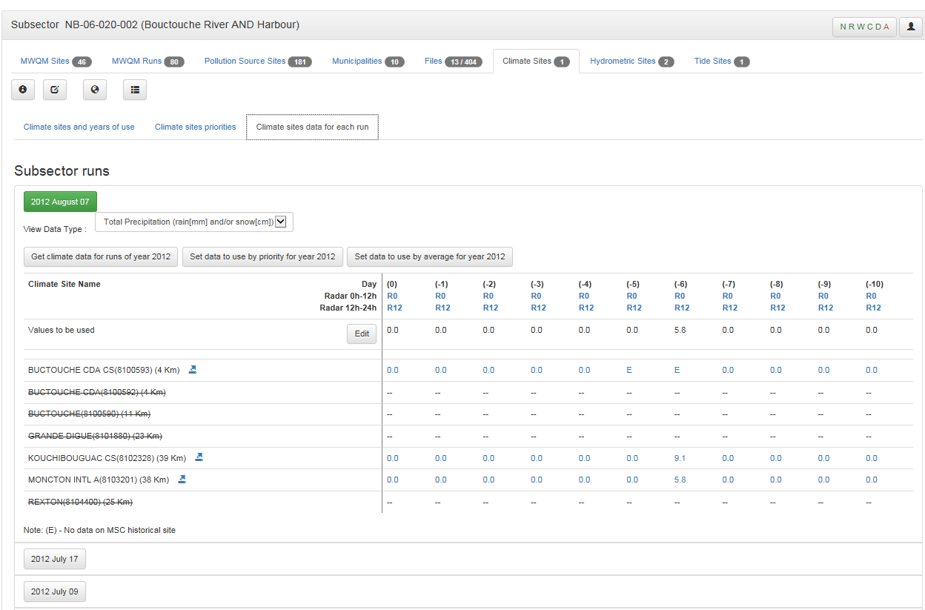

3.4.3.1This section allows you to manipulate the climate site data used for a specific run or a specific year and to view the raw climate data. By default, the data showed will be for the last run in the database. You can close this data by clicking on the green button showing the date of the run on top and scrolling/clicking on the desired date.

The view Data Type scroll down box will let you filter what type of climate data you want to view (total precipitation, rainfall, temperature, etc.).

The next section has the raw data for each climate site selected at the first step (3.4.1). If a site is scratched out, this mean there is no data for that specific year. The arrow next to the climate site name opens a new web page to the raw data on the http://climate.weather.gc.ca/... page. You can also navigate to the radar information by clicking on the R0 (radar 12 am to 12pm) or R12 (radar 12pm to

12am) buttons underneath the day of interest (0 = day of sampling, -4 = 4 days before sampling run, etc.). Also, you can click on precipitation values which have blue text to see the hourly climate data values provided by http://climate.weather.gc.ca/ however; no hourly precipitation values are available.

Note: Archived radar images starts as year 2007.

If you have a climate site that is not scratch out but has values of ‘- - ‘ this means the data has not been uploaded from the climate site and you must click on the  to upload it. This will upload the required data for all the runs for the particular year for that subsector. Required data in this case is climate data on the day of the run as well as 10 days before the run.

Lastly, once the data is uploaded, you can easily set the data for that subsector for the whole year using or use an average of the climate site selected for that subsector for the whole year by clicking on the button.

3.4.3.2 If you click on the 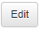 next to the ‘values to be used’ area, new options will be available to you :

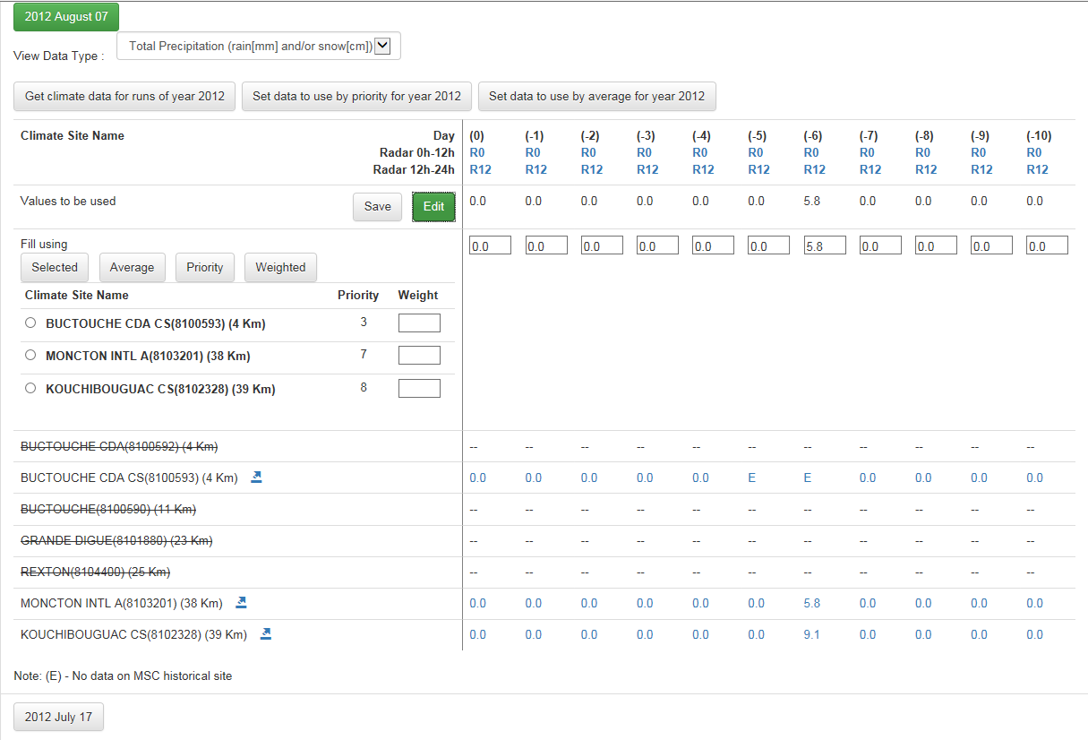

Here, you can either type in the values to be used and click on the button or you can modify/use the priority that you set previously or the average or weighted values of each climate site for the specific date without affecting the other sampling runs climate information previously set.

-If you want to change the data for a specific run, select the climate site you want the data to be used from and click on the button and then on the save button.

-If you want to use the average of the available climate site data for that run, click on the button and then on the save button.

-If you want to use the preset priorities that you have selected previously, click on the button and then on the save button.

Note: if you had already set the data to use by priority for the whole year using the button, clicking on the priority button under the edit function will not have any additional effect.

-If you wish to use multiple climate stations but in different proportions, use the ‘Weighted’ function by typing in the values in the ‘Weight’ box next to each climate site name. For instance (see below): if you do not want to use Buctouche CDA and use Moncton A and Kouchoubouguac CS in a 7 to 5 proportion; type those values in the boxes and click on the and then save button. You will see that the values will change using this calculation for total precipitation as an example:

(Rain value Moncton x 7) + (Rain value Kouchibouguac x 5)

Total of weight values (7+5)

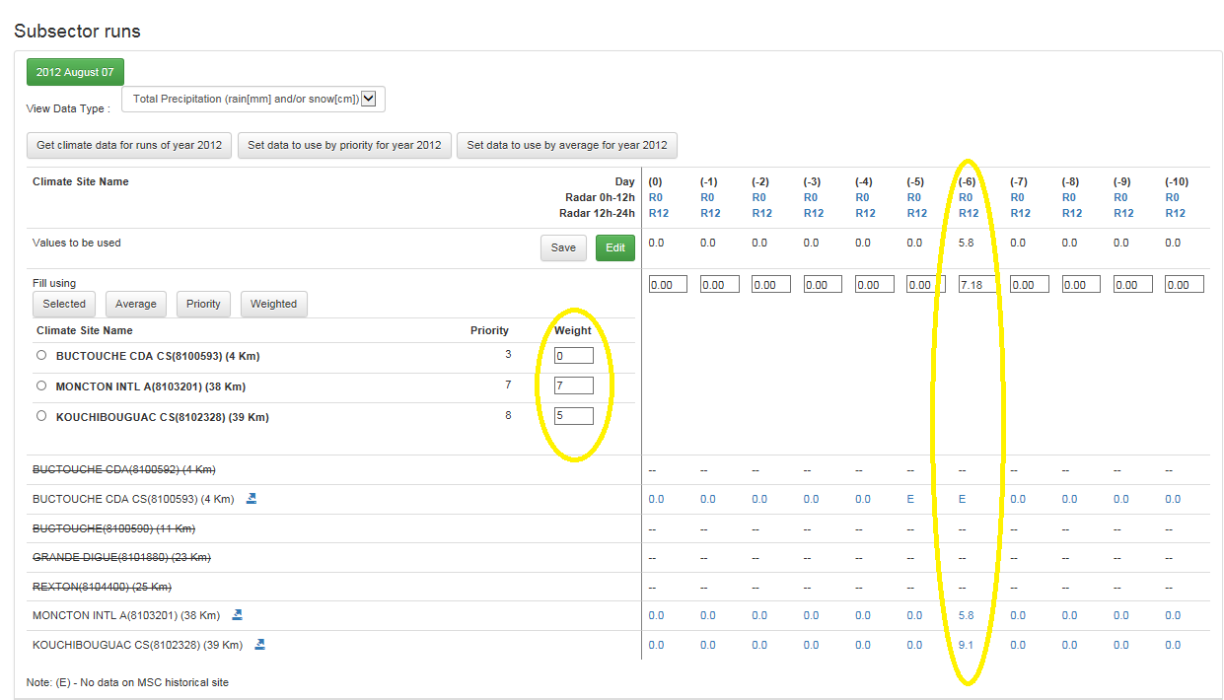

- MAINTENANCE

For any additional troubleshooting help (errors or bugs), please contact Charles LeBlanc (Charles.leblanc2@canada.ca). For general questions, contact your local CSSP working group committee member.

